

Dr. Ryan, Liu inc.
2019-08-06
Dr. Liu
0212 Brown Street, East Melvin, HI 53454
Phone: 3446867921
Fax: 5768141094

Re: Pamela, Nguyen
PHN: 1086732820
Birthdate: 10-Jan-1998
Address: 923 Jennifer Flat, Martinezfurt, WV 85720
Patient number: 2784749448

To Whom It May Concern:

This is a medical letter to state the above patient is pregnant with expected delivery date of 27-Feb-2025. Hoping this information is satisfactory for your requirements.

Thank you.

Sincerely,
Dr. Ryan, Liu
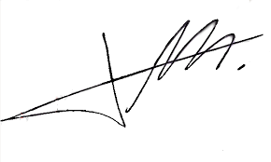
FRCS© NCMP
Clinical Assistant Professor, UBC
Department of Obstetrics and Gynecology SMH

